Chapter 3
Logistic Population Models with Harvesting

3.1 Overview
3.1.1 Malthusian Growth Model
The simplest population model was proposed by Thomas Malthus in 1798. It assumes that the rate of population growth is directly proportional to the current population size:
$\frac{dP }{dt}$= kP
where k > 0 is the intrinsic growth rate. The solution to this equation is:
P(t) = P0 * e^(kt)
This describes unlimited exponential growth. While realistic for small populations with abundant resources, it fails in practice because it predicts that the population grows without bound, which is biologically impossible. This fundamental flaw motivated the development of the logistic growth model.

3.1.2 Logistic Growth Model
To correct the unrealistic assumption of unlimited growth, Pierre François Verhulst introduced the logistic growth model in 1838 by incorporating a carrying capacity N — the maximum population size the environment can sustainably support. The logistic equation is:
$\frac{dP }{dt}$ = kP (1 - P/N)
The term (1 - P/N) acts as a braking factor. When P is much smaller than N, the term is close to 1 and growth is nearly exponential. As P approaches N, the term approaches 0 and growth slows. If P exceeds N, the term becomes negative and the population declines back toward N. The analytic solution is:
P(t) = N / (1 + ((N - P0) / P0) * e^(-kt))
This produces the characteristic S-shaped (sigmoidal) growth curve observed in many real populations.

3.1.3 Equilibrium Points
An equilibrium point (also called a steady state) is a value of P at which the population no longer changes over time. It is found by setting the right-hand side of the ODE equal to zero:
$\frac{dP }{dt}$= 0
For the basic logistic model $\frac{dP }{dt}$= kP (1 - P/N), setting the equation to zero gives:
kP (1 - P/N) = 0
This yields two equilibrium points: P = 0 (extinction) and P = N (carrying capacity). At these values the population remains constant indefinitely, provided no external forces act upon it.

3.1.4 Stability Analysis
Not all equilibrium points behave the same way. An equilibrium is classified as stable if nearby populations return to it over time, and unstable if nearby populations move away from it. Stability is determined by linearization — computing the derivative of f(P) with respect to P and evaluating it at the equilibrium point:
λ = $\frac{df }{dP}$ evaluated at P = P* (equilibrium points)
The stability criterion is:
- If λ < 0 → the equilibrium is stable (population returns after small disturbance)
- If λ > 0 → the equilibrium is unstable (population moves away after small disturbance)
- If λ = 0 → the test is inconclusive
For the logistic model, f(P) = kP(1 - P/N), so:
$\frac{df }{dP}$= k(1 - 2P/N)
At P = 0:
λ = k (1 - 0) = k > 0 → unstable
At P = N:
λ = k (1 - 2N/N) = k(1 - 2) = -k < 0 → stable
This confirms that the carrying capacity N is the stable long-term equilibrium of the logistic model.

3.1.5 Phase Portrait and Slope Field
A phase portrait is a plot of dP/dt versus P. It shows the rate of change of the population at every value of P without solving the ODE explicitly. Where the curve is above zero, the population is growing. Where it is below zero, the population is declining. Where it crosses zero, an equilibrium exists.
A slope field (also called a direction field) is a plot in the t-P plane where small arrows are drawn at each point (t, P) with slope equal to dP/dt at that point. It provides a visual picture of how solution curves behave over time for different initial conditions. Solution curves always follow the direction of the arrows. Equilibrium solutions appear as horizontal lines in the slope field.
Both tools are especially useful for non-autonomous ODEs where an analytic solution is difficult or impossible to obtain.
3.2 Logistic Growth with Constant Harvesting
3.2.1 Model Formulation
In the constant harvesting model, it is assumed that a fixed number of fish, denoted by a, are removed from the population per unit time regardless of the current population size. Adding this harvesting term to the logistic growth equation gives the following first-order ordinary differential equation:
$\frac{dP}{dt}$ = kP (1 - P/N) - a
where:
b | Description | Unit
P | Size of the fish population at time t | number of fish
t | Time | years or seasons
k | Intrinsic growth rate | per unit time
N | Carrying capacity of the environment | number of fish
a | Constant harvesting rate | fish per unit time
This equation states that the rate of change of the population at any time is equal to the natural logistic growth minus the constant amount removed by harvesting. When a = 0, the equation reduces to the standard logistic model with no harvesting.
3.2.2 Equilibrium Analysis
Equilibrium points are found by setting dP/dt = 0:
kP (1 - P/N) - a = 0
Expanding the left-hand side:
kP - kP²/N - a = 0
Multiplying through by -N/k:
P² - NP + aN/k = 0
This is a quadratic equation in P with coefficients:
A = 1, b = -N, c = aN/k
Applying the quadratic formula P = (-b ± sqrt (b² - 4Ac)) / 2A:
P = (N ± sqrt (N² - 4aN/k)) / 2
This gives two equilibrium points:
P1 = (N + sqrt (N² - 4aN/k)) / 2
P2 = (N - sqrt (N² - 4aN/k)) / 2
The existence of real equilibrium points depends entirely on the discriminant:
D = N² - 4aN/k
3.2.3 Discriminant Condition
The discriminant D = N² - 4aN/k determines the number and nature of equilibrium points. Three cases arise:
Case 1: D > 0 — Two distinct equilibria
Condition: a < kN/4
Two distinct real equilibrium points P1 and P2 exist. The population can survive if the initial condition is above P2.
Case 2: D = 0 — One equilibrium (MSY point)
Condition: a = kN/4
The two equilibria merge into a single point at P* = N/2. This is the critical boundary called the Maximum Sustainable Yield. Any harvesting beyond this point leads to extinction.
Case 3: D < 0 — No real equilibria
Condition: a > kN/4
No real equilibrium points exist. The harvesting rate exceeds what the population can recover from and the population declines to extinction regardless of the initial condition.
3.2.4 Maximum Sustainable Yield
The Maximum Sustainable Yield (MSY) is the largest harvesting rate a that still permits the population to sustain itself indefinitely. It is found by setting the discriminant equal to zero:
D = 0
N² - 4aN/k = 0
Solving for a:
MSY = kN/4

For D=0:
P1 = (N + sqrt(D)) / 2 and P2 = (N - sqrt(D)) / 2
Or, P1 = (N + 0) / 2 = N/2 and P2 = (N - 0) / 2 = N/2
At this harvesting rate the two equilibria merge at:
P* = N/2
This means the MSY is achieved when the population is maintained at exactly half its carrying capacity. For the parameters (k = 0.20, N = 5):
MSY = (0.20 x 5) / 4 = 0.25
Any harvesting rate above 0.25 will drive the population to extinction.

3.2.5 Stability Analysis
To classify the stability of each equilibrium point, the linearization method is applied. Let:
f(P) = kP (1 - P/N) - a
The derivative with respect to P is:
$\frac{df }{dP}$ = k (1 - 2P/N)
At P1:
Since P1 = (N + sqrt(D))/2 is greater than N/2, substituting into the derivative gives:
$\frac{df }{dP}$ = k (1 - 2P1/N) < 0
Since the eigenvalue is negative, P1 is a stable equilibrium. Populations near P1 will return to it after a small disturbance.
At P2:
Since P2 = (N - sqrt(D))/2 is less than N/2, substituting into the derivative gives:
$\frac{df }{dP}$= k (1 - 2P2/N) > 0
Since the eigenvalue is positive, P2 is an unstable equilibrium. Populations above P2 recover toward P1, while populations below P2 decline to extinction.
This result has a critical biological interpretation: P2 acts as a danger threshold. If the fish population ever falls below P2 — due to overharvesting, environmental shock, or disease — it will continue to decline and cannot recover on its own.

3.2.6 Parameter Table and Equilibrium Values
Using the parameters k = 0.20 and N = 5, the equilibrium points are computed as:
P1, P2 = (5 ± sqrt (25 - 20a)) / 2
Equilibrium Points for Varying Harvesting Rate (k = 0.20, N = 5)
a | Discriminant D | P1 (stable) | P2 (unstable) | Status
0.00 | 25.000 | 5.0000 | 0.0000 | Two equilibria
0.21 | 4.000 | 3.5000 | 1.5000 | Two equilibria
0.22 | 3.000 | 3.3660 | 1.6340 | Two equilibria
0.23 | 2.000 | 3.2071 | 1.7929 | Two equilibria
0.24 | 1.000 | 3.0000 | 2.0000 | Two equilibria
0.25 | 0.000 | 2.5000 | 2.5000 | MSY — saddle node
0.26 | -1.000 | — | — | Extinction

Table 3.1: Equilibrium Points for Varying Harvesting Rate
As a increases, P1 decreases and P2 increases — the two equilibria move closer together. At a = 0.25 they meet at P* = 2.5. Beyond this point no sustainable equilibrium exists.

3.2.7 Results and Plots
The following figures present the graphical results of the constant harvesting model using the parameters k = 0.20, N = 5, and varying values of the harvesting rate a. Five figures are presented: the equilibrium map, the phase portrait, and three slope field plots corresponding to the three discriminant cases identified in Section 3.2.3.
Equilibrium Map (P1 and P2 vs a)
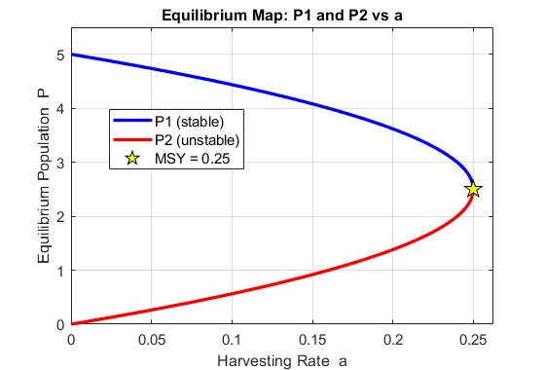
Fig 3.1 — Equilibrium Map (P1 and P2 vs a)
The equilibrium map shows both P1 and P2 plotted as continuous curves against the harvesting rate a ranging from 0 to the MSY. As a increases from 0, P1 decreases from N while P2 increases from 0. The two curves meet at the MSY point (a = 0.25, P = 2.5), forming a characteristic saddle-node bifurcation. Beyond this point both curves become undefined, indicating extinction.

Phase Portrait (dP/dt vs P)
The phase portrait plots dP/dt against P for the constant harvesting equation with a = 0.21. The curve crosses the horizontal axis at P2 = 1.5 and P1 = 3.5. Between these two points the curve is positive meaning the population is growing. Outside this interval — below P2 and above P1 — the curve is negative meaning the population is declining. The green shaded region indicates the growth zone and the red shaded region indicates the decline zone.
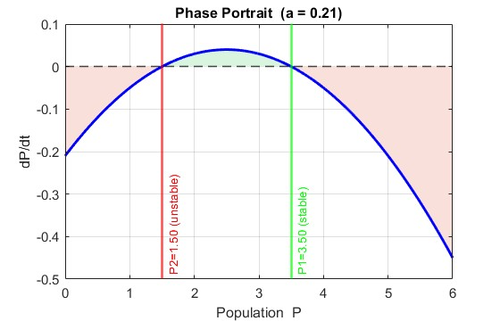
Fig 3.2 — Phase Portrait (dP/dt vs P)
The two zero crossings directly correspond to the unstable equilibrium P2 = 1.5 and the stable equilibrium P1 = 3.5. The phase portrait confirms the stability classification from Section 3.5 — at P2 the curve crosses from negative to positive going left to right, which corresponds to an unstable equilibrium, while at P1 the curve crosses from positive to negative, which corresponds to a stable equilibrium.

Slope Field and Trajectories for a < MSY (a = 0.21)
The slope field and solution trajectories for the constant harvesting model when the harvesting rate a = 0.21 is below the MSY of 0.25. Multiple initial conditions are plotted ranging from P0 = 0.5 to P0 = 5.5 to illustrate the behavior of the system from different starting populations.
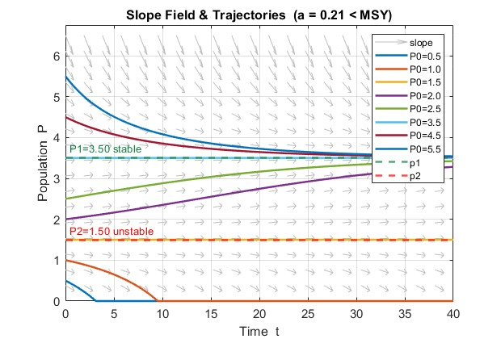
Fig 3.3 — Slope Field and Trajectories for a < MSY (a = 0.21)
The slope field shows arrows that are nearly horizontal near P1 = 3.5, confirming that it is a stable equilibrium. Near P2 = 1.5 the arrows diverge — pointing upward above P2 and downward below P2 — confirming its unstable nature. All solution curves starting above P2 = 1.5 converge toward the stable equilibrium P1 = 3.5 over time regardless of whether they start above or below P1. Solution curves starting below P2 = 1.5, specifically P0 = 0.5 and P0 = 1.0, decline monotonically toward zero confirming the danger threshold behavior of P2.

Slope Field and Trajectories at a = MSY (a = 0.25)
The slope field and solution trajectories when the harvesting rate equals exactly the MSY of 0.25. At this critical value the discriminant D = 0 and the two equilibria merge into a single point at P* = N/2= 2.5.
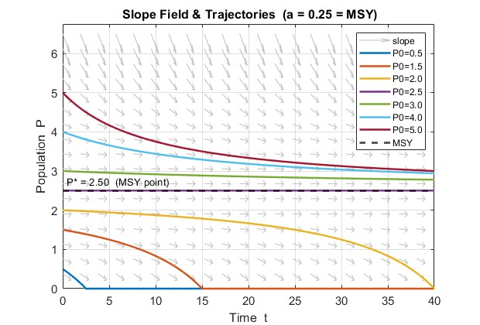
Fig 3.4 — Slope Field and Trajectories at a = MSY (a = 0.25)
The behavior at the MSY is qualitatively different from the a = 0.21 case. Solution curves starting above P* = 2.5 converge very slowly toward P* from above, while solution curves starting below P* = 2.5 decline to extinction. The convergence from above is noticeably slower than in the a = 0.21 case because the merged equilibrium is only marginally stable — the derivative df/dP equals exactly zero at this point making recovery extremely slow. The system is at its most delicate balance and any slight increase in harvesting beyond this point will cause complete collapse.

Slope Field and Trajectories for a > MSY (a = 0.26)
The slope field and solution trajectories when the harvesting rate a = 0.26 exceeds the MSY of 0.25. At this value the discriminant D = -1 and no real equilibria exist.
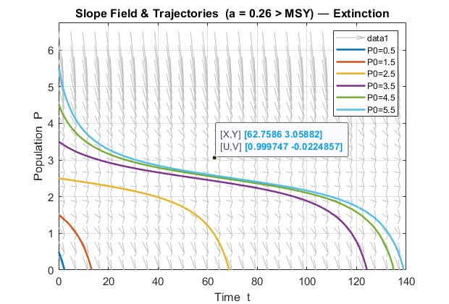
Fig 3.5 — Slope Field and Trajectories for a > MSY (a = 0.26)
When the harvesting rate exceeds the MSY no equilibrium exists. All solution curves regardless of initial condition decline monotonically to zero. This confirms that harvesting beyond the MSY inevitably leads to population extinction.

3.2.8 Summary
This chapter presented the logistic growth model with constant harvesting defined by the equation dP/dt = kP (1 - P/N) - a. The model was analyzed mathematically and numerically using the parameters k = 0.20, N = 5, and varying values of the harvesting rate a.
The equilibrium analysis showed that setting dP/dt = 0 produces a quadratic equation whose solution gives two equilibrium points P1 and P2. Using the quadratic formula the equilibria were found to be:
P1 = (N + sqrt (N² - 4aN/k)) / 2 (stable)
P2 = (N - sqrt (N² - 4aN/k)) / 2 (unstable)
Stability analysis using linearization confirmed that P1 is a stable equilibrium toward which all populations starting above P2 converge, and that P2 is an unstable threshold below which all populations decline to extinction.
The discriminant condition D = N² - 4aN/k identified three distinct cases. When a < MSY two real equilibria exist and the population is sustainable. When a = MSY the two equilibria merge at P* = N/2 = 2.5, representing the most critical boundary of sustainable harvesting. When a > MSY no real equilibria exist and the population collapses to extinction regardless of its initial size.
The Maximum Sustainable Yield was derived analytically as MSY = kN/4 = 0.25, establishing a hard upper limit for safe harvesting. The equilibrium table confirmed that as the harvesting rate increases from 0 to 0.25, P1 decreases and P2 increases until they meet at the MSY point. Beyond a = 0.25 no sustainable harvesting is possible.
The graphical results including the equilibrium map, phase portrait, and slope field plots visually confirmed all analytical findings. The equilibrium map showed the narrowing of the safe harvesting window as a increases. The phase portrait clearly identified the growth and decline zones of the population. The slope field plots demonstrated the convergence of trajectories toward P1 for a < MSY, the slow marginal convergence at a = MSY, and the complete extinction of all trajectories for a > MSY.
Taken together the results of this chapter establish a complete mathematical framework for understanding constant harvesting. Chapter 4 extends this analysis to the more realistic case of periodic harvesting where the harvesting rate varies sinusoidally over time.
3.3 Logistic Growth with Periodic Harvesting
3.3.1 Model Formulation
In reality, fishing activity does not occur at a constant rate throughout the year. Fishing grounds are opened and closed according to seasons, weather conditions, and regulatory schedules. To model this more realistic scenario, the constant harvesting term a is replaced by a sinusoidal function that oscillates over time. The resulting periodic harvesting model is:
$\frac{dP}{dt}$ = kP (1 - P/N) - a (1 + sin(bt))
where:
Parameter | Description | Unit
P | Size of the fish population at time t | number of fish
t | Time | years or seasons
k | Intrinsic growth rate | per unit time
N | Carrying capacity of the environment | number of fish
a | Harvesting amplitude — controls intensity of harvesting | fish per unit time
b | Angular frequency — controls how often harvesting cycles occur | radians per unit time

The term a(1 + sin(bt)) represents a harvesting rate that oscillates between 0 and 2a over time. When sin(bt) = 1 the harvesting is at its peak intensity of 2a. When sin(bt) = -1 the harvesting drops to zero, representing a closed fishing season. When sin(bt) = 0 the harvesting equals a, representing the average rate. This structure naturally captures the opening and closing of fishing seasons throughout the year.
3.3.2 Role of Parameter a
The parameter a controls the amplitude and average intensity of harvesting. It determines how much fish is removed on average per unit time and how large the seasonal swings are.
When a is small the oscillations are mild and the population recovers sufficiently between fishing seasons. As a increases toward MSY = kN/4 the peak harvesting rate reaches 2a, which can temporarily push the population below its safe threshold. Even with partial recovery during the closed season, repeated exposure to high peak rates causes a net downward trend over time. This is why the effective safe harvesting limit in the periodic model is lower than the MSY derived for the constant model — the oscillations introduce additional stress that constant harvesting does not capture.
3.3.3 Role of Parameter b
The parameter b controls the frequency of the harvesting cycle. The period of one complete cycle is:
Period = 2π / b

Value of b | Period | Biological Meaning
0.5 | 12.57 | Long slow cycles — extended recovery periods
1.0 | 6.28 | Standard seasonal fishing
2.0 | 3.14 | More frequent harvesting — less recovery time
4.0 | 1.57 | Very frequent short seasons

When b is small the harvesting cycles are long and slow. The population experiences long periods of low harvesting during which it can recover substantially before the next peak. When b is large the harvesting cycles are short and rapid. The population is hit repeatedly with peak harvesting before it has time to recover, causing a stronger cumulative downward pressure on the population even if the average harvesting rate a remains the same.
3.3.4 Why No Analytic Solution Exists
The constant harvesting model $\frac{dP}{dt}$= kP (1 - P/N) - a is an autonomous ODE because the right-hand side depends only on P and not on time t. This allowed the equation to be solved analytically using separation of variables and partial fractions.
The periodic harvesting model $\frac{dP}{dt}$ = kP(1 - P/N) - a(1 + sin(bt)) is a non-autonomous ODE because the sine term introduces an explicit dependence on time t. This has two important consequences.
First, separation of variables is no longer possible. When attempting to separate the equation: dP / [kP(1 - P/N) - a(1 + sin(bt))] = dt
the left-hand side contains both P and t mixed together through the sine term, making clean separation impossible.
Second, the concept of fixed equilibrium points breaks down. In the autonomous case dP/dt = 0 gave fixed values P1 and P2 that did not change with time. In the non-autonomous case setting $\frac{dP}{dt}$= 0 gives: kP(1 - P/N) = a(1 + sin(bt))
The right-hand side changes with every value of t, meaning the equilibrium position itself shifts continuously over time. There are no fixed steady states — only time-varying quasi-equilibria that oscillate with the harvesting cycle.
For these reasons no closed-form analytic solution exists for the periodic harvesting model and the solution must be obtained entirely through numerical methods.

3.3.5 Results and Plots
The following figures present the graphical results of the periodic harvesting model using the parameters k = 0.20, N = 5, and b = 1.0. Four figures are presented for two values of the harvesting rate — a = 0.21 (below MSY) and a = 0.25 (at MSY) — showing both the slope field and solution trajectories for each case. A fifth figure examines the effect of varying the frequency parameter b.
Slope Field for Periodic Harvesting (a = 0.21, b = 1.0)
Unlike the constant harvesting slope field which shows uniform horizontal arrows near the equilibrium, the periodic harvesting slope field shows arrows that vary in direction depending on both P and t. This time-dependent variation is a direct visual consequence of the non-autonomous nature of the equation. The arrows oscillate in direction across time, reflecting the periodic rise and fall of the harvesting rate.
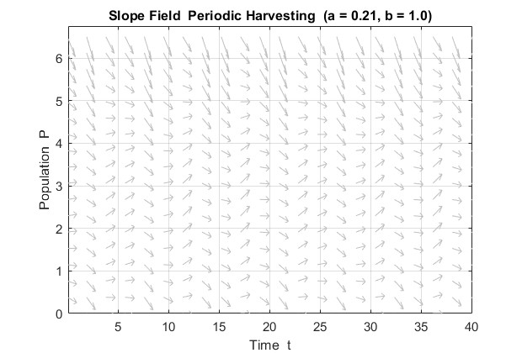
Fig 3.6 — Slope Field for Periodic Harvesting (a = a1 = 0.21)
In the constant harvesting slope field, the arrows are uniform across time — at any given population level P the arrow direction does not change with t. In the periodic harvesting slope field, the arrows change direction periodically across the time axis, showing that the rate of population change depends not only on the current population size but also on the current phase of the harvesting cycle.
Trajectories for Periodic Harvesting (a = 0.21, b = 1.0)
For a = 0.21, which is below the MSY of 0.25, the population trajectories show a characteristic oscillating behavior. Instead of converging smoothly to a fixed equilibrium as in the constant harvesting model, the population rises and falls repeatedly in response to the sinusoidal harvesting cycle. Populations starting above approximately P = 1.5 settle into a sustained oscillation around a mean value below N. Populations starting very low such as P0 = 0.5 and P0 = 1.0 decline toward extinction during the early peak harvesting phase before the closed season can allow sufficient recovery.
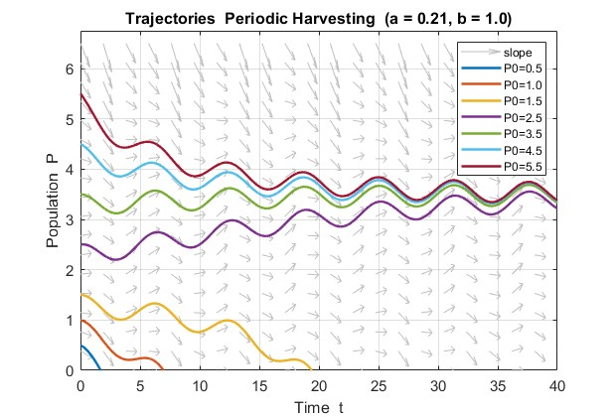
Fig 3.7 — Trajectories for Periodic Harvesting (a = a1 = 0.21)
The oscillating trajectories confirm that the periodic model produces no fixed steady state. The sustained oscillations observed for higher initial conditions represent the long-term behavior of the system — the population permanently cycles between a peak during the closed season and a trough during the open season.
Slope Field for Periodic Harvesting (a = 0.25, b = 1.0)
At a = 0.25 the slope field shows more aggressively downward-pointing arrows compared to the a = 0.21 case. This reflects the fact that the peak harvesting rate now reaches 2 x 0.25 = 0.50, which is double the MSY. The slope field clearly shows that for most values of P the population is being driven downward during peak harvesting periods.
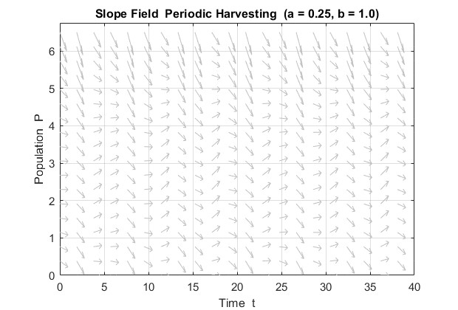
Fig 3.8 — Slope Field for Periodic Harvesting (a = a2 = 0.25)

Trajectories for Periodic Harvesting (a = 0.25, b = 1.0)
At a = 0.25 the effect of the sine function becomes fully apparent. The trajectories still oscillate but the oscillations are larger in amplitude and the mean population level shows a clear downward trend over time compared to the a = 0.21 case. Trajectories that appeared sustainable at a = 0.21 now decline progressively, demonstrating that the periodic harvesting model reaches its effective limit at a value lower than the theoretical MSY of the constant model.
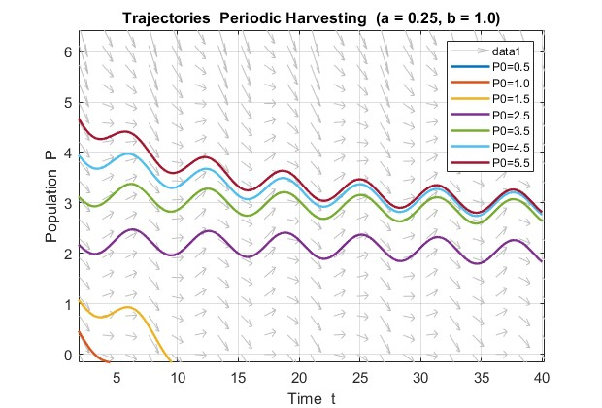
Fig 3.9 — Trajectories for Periodic Harvesting (a = a2 = 0.25)
At a = 0.21 the oscillating trajectories stabilize around a sustained mean level. At a = 0.25 the trajectories oscillate but the mean level drifts downward with each successive cycle. The low initial conditions P0 = 0.5 and P0 = 1.0 reach extinction faster than in the a = 0.21 case. This progressive decline under a = 0.25 demonstrates that setting the periodic harvesting rate equal to the constant model MSY is already unsustainable in practice.
3.3.6 Effect of Parameter b
To investigate how harvesting frequency affects population dynamics, the parameter b is varied while keeping all other parameters fixed at k = 0.20, N = 5, a = 0.21, and P0 = 4.0.
Effect of Frequency b (b = 0.5, 1, 2, 4)
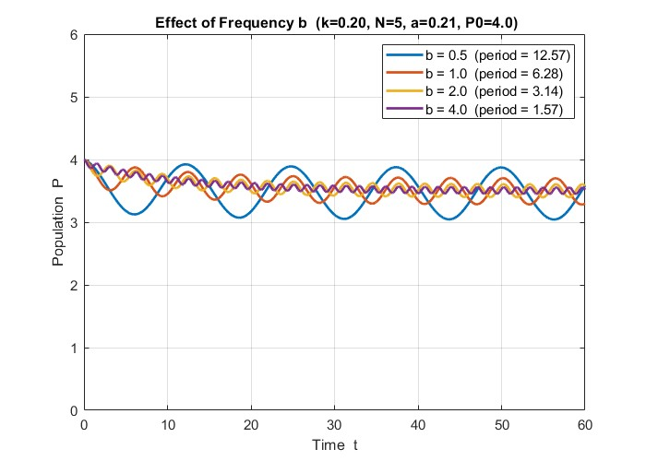Fig 3.10 — Trajectories for Varying b (b = 0.5, 1, 2, 4)
The figure shows all four trajectories plotted together on the same axes, allowing direct comparison of the effect of harvesting frequency on population dynamics for the same initial condition P0 = 4.0 and the same average harvesting rate a = 0.21.

3.3.7 Summary
This chapter presented the logistic growth model with periodic harvesting defined by dP/dt = kP(1 - P/N) - a(1 + sin(bt)), analyzed numerically using MATLAB's ode45 with parameters k = 0.20, N = 5, and b = 1.0.
The non-autonomous nature of the equation — caused by the explicit dependence of the sine term on time t — means no analytic solution exists and no fixed equilibrium points can be derived. The equilibrium position shifts continuously with the harvesting cycle, making numerical integration the only viable approach.
The numerical results showed that the population never reaches a fixed steady state but oscillates continuously in response to the harvesting cycle. At a = 0.21 the population sustains a stable oscillation around a mean level lower than P1 = 3.5 of the constant model. At a = 0.25 the mean population level declines progressively over time, confirming that the effective safe harvesting limit of the periodic model is lower than the MSY of the constant model.
The frequency parameter b showed that lower b produces larger amplitude oscillations that are more damaging to the population, while higher b smooths out the harvesting stress and reduces oscillation amplitude.
Overall the periodic model is more realistic but more demanding than constant harvesting — the same average rate a produces a lower sustained population due to the additional stress of peak harvesting periods. Chapter 5 directly compares both models through sensitivity analysis.

3.4 Comparison and Sensitivity Analysis
3.4.1 Constant vs Periodic
To directly compare the two harvesting models, both are simulated using identical parameter values: k = 0.20, N = 5, a = 0.21, b = 1.0, and P0 = 4.0. The only difference between the two simulations is the form of the harvesting term — constant a versus periodic a(1 + sin(bt)).

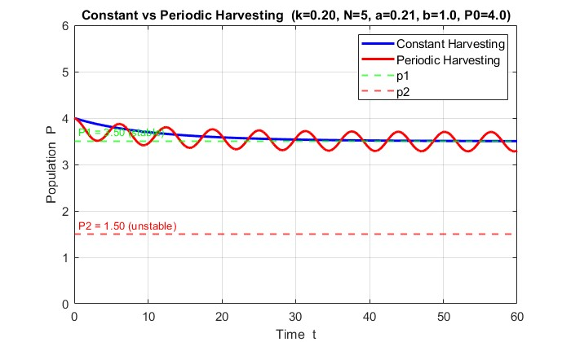
Fig 3.10 — Constant vs Periodic Harvesting
The side-by-side comparison reveals a fundamental difference in long-term population behavior between the two models. Under constant harvesting the population follows a smooth monotonic trajectory that converges to the stable equilibrium P1 = 3.5 and remains there indefinitely. The population settles into a fixed steady state with no further fluctuation.
Under periodic harvesting with the same average harvesting rate a = 0.21, the population never reaches a fixed steady state. Instead it oscillates continuously in response to the sinusoidal harvesting cycle, rising during low-harvest phases and declining during peak-harvest phases..
3.4.2 Which Model is More Realistic
From a biological and management perspective, the periodic harvesting model is more realistic than the constant harvesting model for the following reasons.
Real fisheries do not operate year-round at a fixed rate. Fishing is governed by seasonal regulations, weather patterns, and migration cycles — grounds are opened and closed throughout the year. The sinusoidal function a(1 + sin(bt)) captures this cycle naturally. In contrast the constant model assumes exactly units are removed per unit time regardless of actual population size, which is biologically impossible when fish are scarce.
Furthermore, real fish populations do not sit at a fixed equilibrium. They fluctuate in response to environmental variability and seasonal productivity changes. The oscillating trajectories of the periodic model are conceptually closer to what is observed in real fishery data than the smooth convergence of the constant model.
However, the periodic model also has limitations — a perfect sinusoidal harvesting pattern is still a simplification of irregular real-world fishing activity. Despite this, the periodic model provides a substantially more realistic framework for guiding fishery management decisions and should be preferred as the primary planning tool, with the constant model used as a theoretical reference.

3.4.3 Effect of Growth Rate k
The intrinsic growth rate k represents how rapidly the fish population reproduces under ideal conditions. To isolate its effect, N = 5 and a = 0.21 are held fixed while k is varied across the values 0.10, 0.20, 0.30, and 0.40.
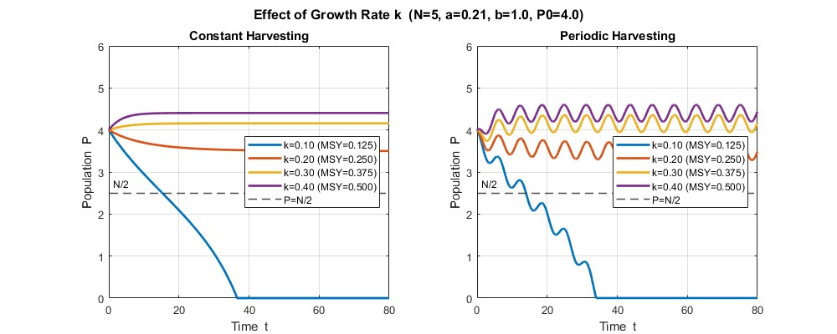

Fig 3.11 — Effect of Varying k on Population Trajectories
As k increases, the MSY (= kN/4) increases proportionally, allowing the population to sustain higher harvesting pressure. At k = 0.10, the MSY of 0.125 falls below a = 0.21, driving the population to extinction under both harvesting modes. For k ≥ 0.20, the population stabilizes at a higher P₁ as k increases. Under periodic harvesting, surviving populations oscillate around mean values that closely match the constant-harvesting equilibria, confirming that the constant model reliably predicts long-run average behavior.

The sensitivity of the equilibrium points to k is summarized below:
Effect of Growth Rate k (N = 5, a = 0.21)
k | MSY = kN/4 | P1 (constant) | P2 (constant) | Status (constant) | Mean P (periodic)
0.10 | 0.1250 | — | — | Extinction | Extinction
0.20 | 0.2500 | 3.5000 | 1.5000 | Sustainable | 3.50
0.30 | 0.3750 | 4.1583 | 0.8417 | Sustainable | 4.16
0.40 | 0.5000 | 4.4039 | 0.5961 | Sustainable | 4.40

Table 3.2 — Effect of Growth Rate
3.4.4 Effect of Carrying Capacity N
The carrying capacity N represents the maximum population size the environment can support. To isolate its effect, k = 0.20 and a = 0.21 are held fixed while N is varied across the values 3, 5, 7, and 10.
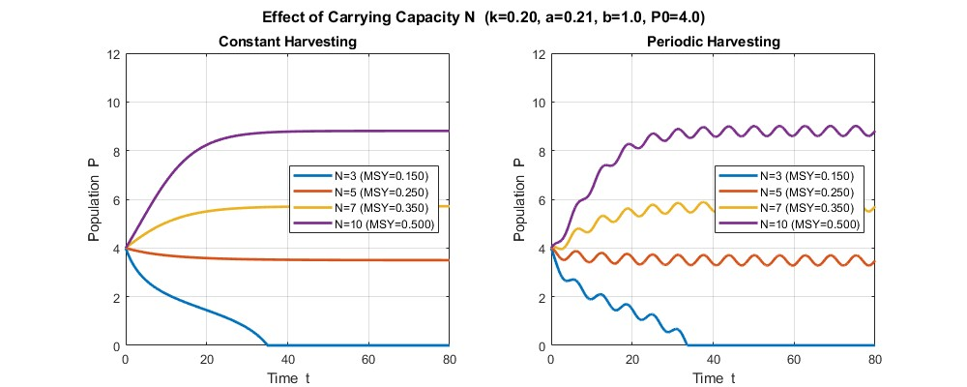
Fig 3.12 — Effect of Varying N on Population Trajectories
Increasing N raises the MSY and shifts P₁ upward, giving the fishery a wider safe operating margin. At N = 3, the MSY of 0.150 falls below a = 0.21 and the population collapses under both harvesting modes. For N ≥ 5, the population stabilizes at progressively higher levels. Periodic harvesting produces oscillations around means that closely match the constant-harvesting P₁ values, again validating the constant model as a practical planning tool.
Effect of Carrying Capacity N (k = 0.20, a = 0.21)
N | MSY = kN/4 | P1 (constant) | P2 (constant) | Status (constant) | Mean P (periodic)
3 | 0.1500 | — | — | Extinction | Extinction
5 | 0.2500 | 3.5000 | 1.5000 | Sustainable | 3.50
7 | 0.3500 | 5.7136 | 1.2864 | Sustainable | 5.72
10 | 0.5000 | 8.8079 | 1.1921 | Sustainable | 8.82
Table 3.3 — Effect of Carrying Capacity N

3.4.5 Effect of Harvesting Rate a
To examine how increasing the harvesting rate drives the system toward extinction, k = 0.20, N = 5, b = 1.0, and P0 = 4.0 are held fixed while a is increased across six values: 0.05, 0.10, 0.15, 0.21, 0.25, and 0.30.
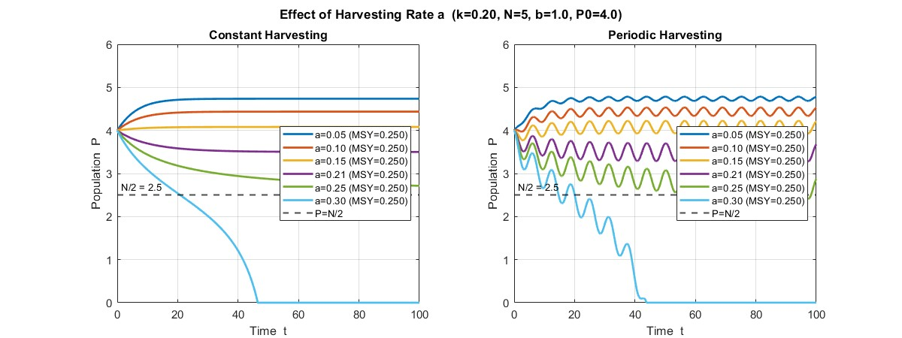
Fig 3.13 — Effect of Harvesting Rate a
This figure shows that both harvesting models share a similar collapse threshold, but respond differently near it. Under constant harvesting, all values of a below 0.25 converge smoothly to stable equilibria above N/2 = 2.5, while a = 0.30 — the only value exceeding the MSY — declines monotonically to extinction. Under periodic harvesting, the same threshold applies, but a = 0.30 collapses more abruptly due to the additional stress of peak harvesting episodes pushing the population below recovery. For sustainable values, periodic harvesting consistently produces a lower mean population than the constant model, with oscillation amplitude increasing as a approaches the MSY boundary at 0.25 — indicating that populations under periodic harvesting operate with a narrower safety margin even when the harvesting rate is technically within the sustainable range.

Effect of Harvesting Rate a on Periodic Harvesting (k = 0.20, N = 5, b = 1.0, P0 = 4.0, MSY = kN/4 = 0.25)
a | Mean P | Min P | Max P | Status
0.05 | 4.7381 | 4.6866 | 4.7850 | Sustainable
0.10 | 4.4395 | 4.3365 | 4.5340 | Sustainable
0.15 | 4.0849 | 3.9288 | 4.2264 | Sustainable
0.21 | 3.4992 | 3.2799 | 3.6987 | Sustainable
0.25 | 2.6926 | 2.4121 | 2.9524 | MSY boundary
0.30 | 0.0000 | 0.0000 | 0.0000 | Extinction
Table 5.3 — Effect of Harvesting Rate a on Periodic Harvesting
As a increases the mean population declines steadily and the gap between minimum and maximum P widens, indicating larger oscillations and greater instability. At a = 0.25 the population is at the MSY boundary with a mean of 2.69, well below the stable equilibrium P1 = 3.5 of the constant model. At a = 0.30 the population reaches complete extinction, confirming that exceeding the MSY under periodic harvesting leads to irreversible collapse.

3.4.6 Summary
This chapter presented a comparison of the constant and periodic harvesting models and a sensitivity analysis of the key parameters k, N, a, b, and P0.
The direct comparison of both models using identical parameters showed that the constant harvesting model converges smoothly to the stable equilibrium P1 = 3.5, while the periodic model oscillates continuously around a lower mean value. This confirmed that periodic harvesting is more stressful to the population than constant harvesting at the same average rate a.
The sensitivity analysis revealed the following key findings. Increasing the growth rate k raises the MSY and shifts P1 upward, while decreasing k — as seen at k = 0.10 — pushes the MSY below the harvesting rate and causes extinction. Increasing the carrying capacity N similarly raises the MSY and widens the safe harvesting window, while a reduced N — as seen at N = 3 — causes the same harvesting rate to become unsustainable. Increasing the harvesting rate a progressively lowers the mean population and widens the oscillation amplitude under periodic harvesting until extinction occurs at a = 0.30. The initial condition P0 was shown to be critical — populations starting below P2 = 1.5 decline to extinction while all populations above P2 survive regardless of their starting value.
The effect of harvesting rate a on the periodic model was quantified in Table 5.3, which showed a clear progressive decline in mean population as a increased from 0.05 to 0.30, with complete extinction occurring beyond the MSY of 0.25.
Overall, the sensitivity analysis confirmed that a, k, and N are the three most critical parameters governing long-term population survival. Chapter 6 summarizes the conclusions and biological implications of the entire study.

